Year 7 Science 2022

**Chemistry 1 Test**

**SECTION 1: MULTIPLE CHOICE** (1 mark each)

Circle your answer on the multiple choice answer sheet.

1. Which **change in state** is illustrated?

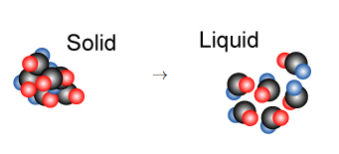

1. Melting
2. Freezing
3. Evaporation
4. Condensation
5. Which best describes a **solid**?
6. Its particles vibrate in place
7. Its particles do not move at all
8. Its particles can flow past each other
9. Its particles are very far apart
10. Which states of matter have **no fixed shape** and **no fixed volume**?
11. Gas and liquid
12. Liquid and solid
13. Plasma and gas
14. Solid and plasma
15. Which statement best describes why gases are **easily compressed**.
16. The particles can diffuse
17. There is a pressure between particles squashing them together
18. There is great energy between the particles allowing them to change
19. There is a lot of a space between the particles.
20. The definition of **melting point** is:
21. the temperature at which a liquid changes to a gas
22. the temperature at which a solid changes to a gas
23. the temperature at which a liquid changes to a solid
24. the temperature at which a solid changes to a liquid.
25. A **physical change** is
26. When a substance is formed
27. One that can easily be reversed.
28. When bubbles, smell or a colour change can be released.
29. Also called a chemical reaction
30. The separation techniques that relies on one substance being **more soluble** than another is
31. combustion.
32. magnetic separation.
33. filtration.
34. evaporation and crystallisation.

.

1. Which of the following would **not** be a physical change?
2. Freezing water to make ice cubes
3. Melting gold to make jewellery
4. Burning gasoline in a lawn mower
5. Boiling water for soup
6. To separate a mixture of **paper clips and sand**, Joe should use
7. Wind separation
8. Distillation
9. Magnetic separation
10. Decanting
11. To separate **two or more liquids**, you would use
12. Distillation
13. Chromatography
14. Centrifugation
15. Filtration
16. Which of the following pictures shows **decantation**?

a) 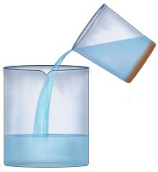b) 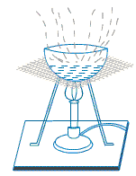

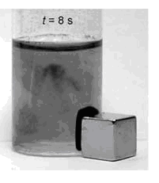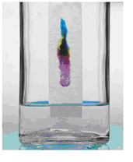

c) d)

1. **Distillation** is not useful for
2. Purifying water
3. Making distilled water
4. Making essential oils or alcoholic liquors
5. Extracting pure salt from sea water
6. A student wishes to obtain **fresh water from salt water**. The best way to do this is by:
7. Filtration
8. Evaporation
9. Distillation
10. Decanting
11. If you were planning to collect salt from sea water, which of the following pieces of apparatus would be of **least use**?
12. Filter funnel
13. Evaporating basin
14. Bunsen burner
15. Tripod
16. **Paper chromatography** is good for separating
17. mixtures of food colours.
18. mixtures of perfumes or flavourings.
19. sugar from sand.
20. gases.



**Chemistry I Test**

**NAME: ______**

**FORM:** **DATE:**

Multiple Choice Short Answer Total

**/30**

**/15**

**/45**

**SECTION ONE:** Multiple choice answers

Cross (X) through the correct answer.

|  |  |  |  |  |
| --- | --- | --- | --- | --- |
| **1** | a | b | c | d |
| **2** | a | b | c | d |
| **3** | a | b | c | d |
| **4** | a | b | c | d |
| **5** | a | b | c | d |
| **6** | a | b | c | d |
| **7** | a | b | c | d |
| **8** | a | b | c | d |
| **9** | a | b | c | d |
| **10** | a | b | c | d |
| **11** | a | b | c | d |
| **12** | a | b | c | d |
| **13** | a | b | c | d |
| **14** | a | b | c | d |
| **15** | a | b | c | d |

**SECTION 2: WRITTEN**

**Write your answers in the spaces on the answer sheet provided.**

1. Label the states of matter and phase changes in the following diagram. (6 marks)

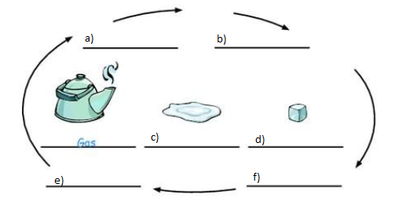

2 Classify the following as solids, liquids or gases.

Air, milk, Ice, Wood, Rain, Rice, Steam, Steel, Snow, Cloud, Rock, Lava (6 marks)

|  |  |  |
| --- | --- | --- |
| **Gas** | **Solid** | **Liquid** |
|  |  |  |
|  |  |  |
|  |  |  |
|  |  |  |
|  |  |  |

1. Explain **step by step** how you would separate a mixture of sand, sugar and iron filings, so that you could recover each part of the mixture in a relatively pure form. (4 marks)

__________________________________________________________________________________________________________________________________________________________________________________________________________________________________________________________________________________________________________________________________________________________________________________________________________________________________________________________________________________________________________________________________________________________________

1. Filtration is used widely around the home and all around us. Give **two** examples of filters used in every-day life. (2 marks)

FILTER A __________________________________________

FILTER B __________________________________________

1. When cooking rice it is important to wash the rice in water to remove the starch on the rice grains. After washing the rice, the water is removed by pouring off the water.

What **type of separation** is this? (1 mark)

__________________________________________________________________________

1. Starting with muddy sea water, name the **separation techniques** you would use to end up with

(3 marks)

1. clean sea water.

________________________________________________________________________

1. dry salt.

________________________________________________________________________

1. pure water.

________________________________________________________________________

1. Match the following words to their correct definition. (6 marks)

|  |  |  |  |  |
| --- | --- | --- | --- | --- |
| **Letter** | **Word** | **Number** | **Definitions** | Match the letter corresponding to the word with the number for the correct definition. Eg. G 7 |
| A | matter | 1 | A substance that will dissolve in a liquid |  |
| B | Solution | 2 | A material made up of two or more different substances which are physically combined. |  |
| C | Mixture | 3 | A substance that is able to dissolve other substances |  |
| D | Solute | 4 | A solution that has dissolved a large amount of solute and is not able to dissolve any more. |  |
| E | Saturated | 5 | A mixture of a solvent and a solute |  |
| F | Solvent | 6 | Anything that takes up space. |  |

1. Label the following diagram (2 marks)

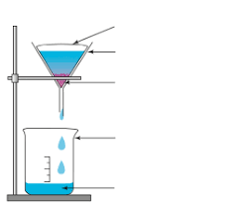

D

C

B

A

|  |  |
| --- | --- |
| **Letter** | **Name** |
| A |  |
| B |  |
| C |  |
| D |  |